Halifax Society for the Blind Newsletter: June 2022

Southgate Here We Come!
It is with great pleasure that we announce the commencement of building works at our new premises on Southgate.
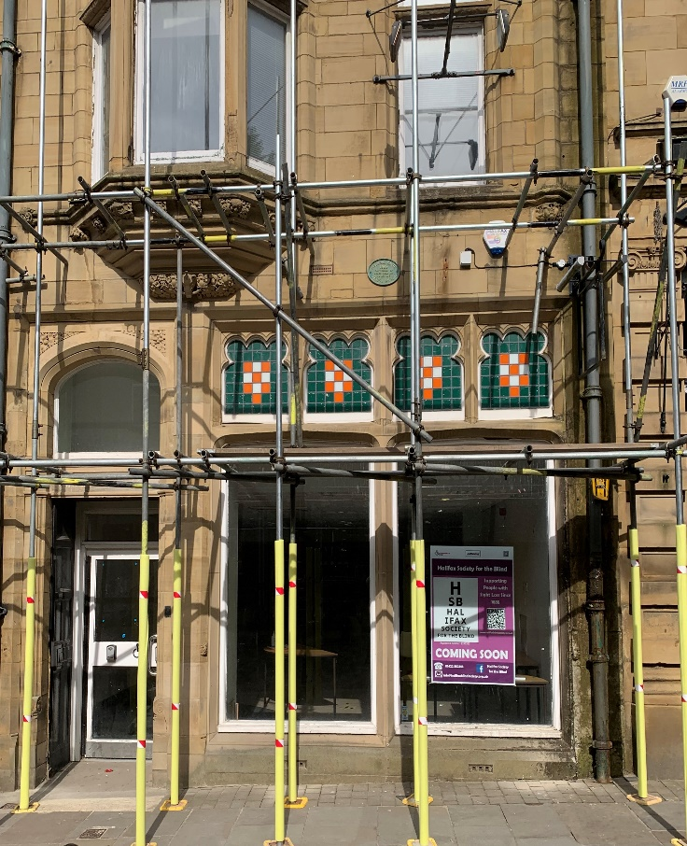
This will be a long-lasting headquarters and hub of sight loss support services in Calderdale, and our Board is keen to make sure it both suits our community’s needs and promotes partnership work with similar organisations.
That’s why we’ve invested over £200,000 to make Southgate an easy and comfortable place to visit – whilst also being a regular place to get your lunch or a cuppa with friends. We hope to open in the Autumn.
The possibilities for increased types of activities and support will be huge, and we welcome ideas from our community and professionals alike. It is also important to note that making a building fit so well with the needs of people with sight loss is a bit like the icing on the cake. We very much hope that people will help us ice that cake, by supporting us with donations to help us achieve this vision. If you would like to make a donation, please contact us on 01422 352383 and we can talk through your options.

Queens Award for Voluntary Services
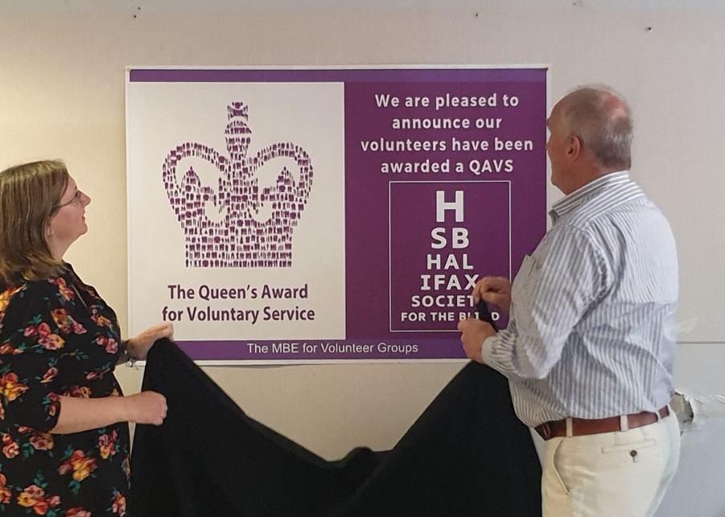
We are delighted to announce that Halifax Society for the Blind has been awarded the Queen’s Award for Voluntary Services.
Equivalent to an MBE, the Queen’s Award for Voluntary Services (QAVS) are the highest awards given to local voluntary groups in the UK, and they are awarded for life.

Created in 2002 to mark the Queen’s Jubilee, the awards have been shining a light on the fantastic work of voluntary services for the last 20 years and it seems particularly special to be awarded the QAVS in the year of the Queen’s Platinum Jubilee.

The official announcement was made on Thursday 2nd June, however we tried to keep the news secret so we could do a big announcement at our Volunteers Celebration and Open Day on 7th June.
We are incredibly proud of the fact that the charity and our volunteers have been recognised in this way.
Official Notice: Annual General Meeting on 9th August 2022
You are warmly invited to our first face-to-face AGM in three years. This will be on Tuesday 9th August at 6pm at the Maurice Jagger Centre in Halifax.
As a member’s organisation, HSB is ultimately driven by you. By attending, you can contribute to HSB’s overall direction by shaping policy, give feedback about our work, and even become a Trustee and help make bigger decisions.
Light refreshments will be served, plus hot and cold drinks.

Introducing…Luke Spink, Sight Support Adviser
Hello! My name is Luke, I’m 27 years old and the new sight support adviser. I’m very much looking forward to meeting and working with all the wonderful people associated with Halifax Society for the Blind!
Being partially sighted myself I was already aware of the great support the organisation provides for its members before the job role became available. Once I left school, my first job was a customer service assistant in a call centre. However, eventually I realised that this job was not for me and decided to further my education at university. I studied Business Studies finishing my course in 2019 and decided to take a risk and accepted a job teaching English in Shanghai, China!
I moved to China at the beginning of 2020, which was just as the Coronavirus started to make itself known to the world. Although these were worrying times being so far away from home, I couldn’t help but still have a blast! I was very lucky to be able to experience this part of the world, however I was seeing it in a state that nobody had ever before. At the end of 2021 I decided I’d had enough and moved back to the UK to start a new career.
I have many interests, firstly I love to watch football! I support Huddersfield Town and go and watch them whenever I can. I also love to travel. Moving and living in China for 2 years showed me that there is so much more to see in the world, and I aim to try and see as much of it as I can. My other interests include, collectibles, video games, and going to the cinema. Well, that’s all from me! I hope this has given you a bit more of an insight into who I am. I’m excited to be given this opportunity and hope to see you all soon. My email is – luke.spink@halifaxblindsociety.org.uk

Activities Update – Upcoming Events to watch out for
Regular Activities at Halifax Society for The Blind
(Contact the office for further details)
Weekly (or most weeks) | When? | Venue
Brighouse Group – friendly gathering of people with sight loss, friends and family for social chat, information and games. | Mondays from 12.30pm to 2.30 pm. | Brighouse Rest Centre.
Tuesday Zoomers - different activities each week (guest speakers, quizzes, information, chat and workshops). | Tuesdays from 11am to noon. | Via Zoom (for details on joining see the back page of newsletter)
Halifax Group – friendly gathering of people with sight loss, friends and family for social chat, information and games. | Wednesdays 2.15-3.45pm (1st, 2nd & 3rd week each month). | Maurice Jaggar Centre, Halifax
Thursday Fun & Games – with quizzes and games, keep yourself fit for fun. Bring your own cuppa! | Thursdays from 11.30am -12.30pm. | Via Zoom.
Chairobics! - 25-minute gentle seated exercise session for all ages and abilities. | Friday at 10am | Via Zoom.
Bowling group - A chance to meet up with friends and other members, to engage in recreational fun. | Every Friday 11.00am | Electric Bowl  70 Commercial Street, Halifax, HX12JE
Less Often… | When? | Venue
Wellbeing Wise - looking after your wellbeing self-help group. | 4th Wednesday each month | Via Zoom.
Synapptic Users Group – share experiences at this mobile phone and tablet user self-help group. | 1st Wednesday of the month, 11am to noon. | Via Zoom.
Guide Dog Owner Group – a chance for current, past, and potential guide dog owners to catch up and share their experiences. | 3rd Wednesday of the month, 11am to noon. | Good Mood Café, Commercial Street, Halifax (at the old toy shop).
Flat Green Bowling - A chance to have a go and learn the rules of flat green bowling, also meet and chat to the members some of whom have sight loss. | Tuesday 28th June 2022.  11.00 – 1.30 | Wellholme Park, Brighouse
Tenpin Bowling - if you are interested in having a go. Contact Tina on 01422 352383. There will be prizes. The cost will be £3.00. | Friday 22nd July 2022  10.00 - 12.00 | Electric Bowl,  70 Commercial Street, Halifax, HX12JE

It Could Be You!
Halifax Society for the Blind is looking for a special person who wants to make a real difference to the lives of people living with sight loss across Calderdale.
Can you motivate people to raise money, organise coffee mornings, concerts and sponsored events? Can you talk to groups and represent our charity across the local community? Are you motivated by success and get satisfaction from seeing the difference you have made? Hours and days can be very flexible to suit the right person and fit around other roles. Some evening and weekend work would be needed. In return we offer a good salary and great working conditions.
Want to know more? Just email brief details about yourself to the Chief Officer at pete.hoey@halifaxblindsociety.org.uk and we’ll get back to you.

Bose Frames – What are they?
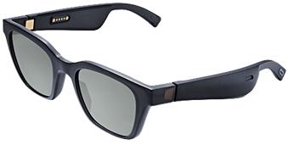
Bose frames - a decent pair of sunglasses with a pair of headphones that have micro speakers in each arm and direct a beam of sound to your ears. With nothing in your ears, you can still hear what’s going on around you whilst:
• listening to music/talking books
• taking phone calls
• navigating an area with Soundscape for Apple, Google maps with Android
The sunglasses connect with your smart phone via Bluetooth, and with Bose connect app you get complete control of your smartphone with Siri or Talkback while it remains in your pocket or bag. Contact the office for more details.

VI Friendly Credit Card from NatWest and Royal Bank of Scotland
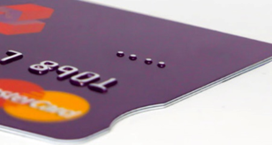
Nat West and Royal Bank of Scotland have launched a new credit card to complement their existing VI friendly debit card.
The RNIB-approved credit cards launched by NatWest have a notch cut out on the right-hand side to help visually impaired customers insert them into ATMs and PIN pads the right way.
The card is not embossed but is printed 50% larger to make it easier to see. The debit card has two vertical lines on the right, the credit card two horizontal lines on the right to distinguish between the two.
Customers can order a Braille plastic wallet to help with reading the card information such as the account number, expiry date etc. This can only be done in branch with their card and cannot be done over the phone for security reasons. The reverse of the card has also been adapted with the telephone numbers placed where no embossing will be, and the font increased by more than 50% to make it easier to read.

Volunteer Celebration and Open Day
On Tuesday 7th June we held a successful Volunteer Celebration and Open Day at our new building in Southgate.
Once our wonderful team of volunteers had arrived, we unveiled the extremely exciting news that Halifax Society for the Blind has been awarded the Queen’s Award for Voluntary Service.
Colin Hutchinson, one of our trustees attended the event to thank each volunteer individually for their contribution by presenting them with a certificate, a QAVS pin badge and a small thank you gift.
The rest of the day was spent welcoming new people, discussing the various voluntary roles we have available and tours around the building. There were lovely quotes from our volunteers posted along the walls along with information about activities that take place regularly. Some of the quotes were:
“Volunteering has given me my confidence and my purpose back.”
“Knowing that you can make a difference to someone’s life in a positive way is joyous”
If you or someone you know would be interested in volunteering for our charity, then please get in touch on 01422 352383.
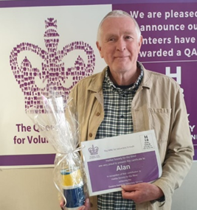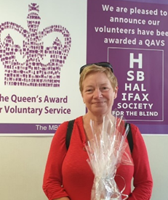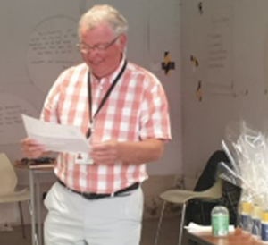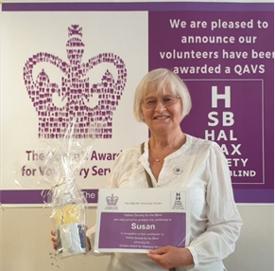

Morecambe Trip 27th April 2022
The opportunity to visit Morecambe and the wonderful Brew Me Sunshine café was swiftly taken up by dozens of members. Seats went like hot cakes and within two weeks they were all taken. In all, 47 members, staff, volunteers and Trustees enjoyed the trip. Those who wanted were picked up from their own home, and dropped back, which is now our preferred way of running transport on such events.
The weather was lovely and after a welcome cuppa on arrival at Brew Me Sunshine we heard from Tony Kimpton, a visually impaired trustee at Galloways Society for the Blind. Then we had a tour of the extremely well-designed sight centre, which sits alongside the café. People then had time for a walk along the prom, and it is believed that some even made it to a local hostelry!
It was a long day, but all returned home safely, having enjoyed a nice lunch, learnt new things about great premises design, and (importantly nowadays), we all got out in the fresh air and had a wonderful day out. We are very grateful to our hosts at Galloways and look forward to welcoming them to our new centre when it opens in the Autumn.

Focused on Delivery
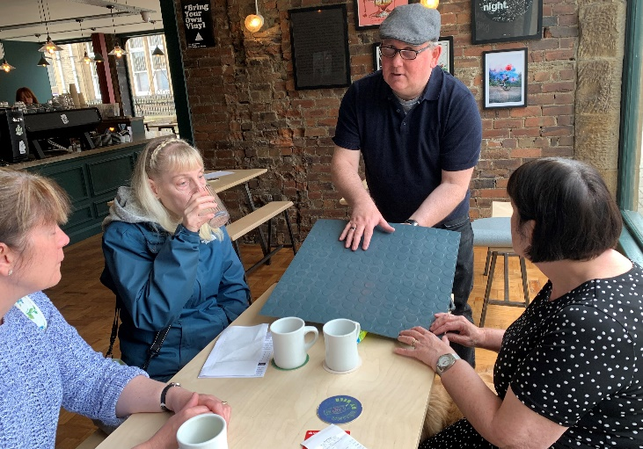
On 1st June, we held a focus group to get your views around planning our new premises at Southgate. The discussions were wide-ranging, including seating and tables in the social café. Comfortable seating, with emphasis on the space between tables being preserved was a high priority, as well as having a cheery look to the place. We also discussed the overall feel of the building, with importance laid on the promotion of independent wayfinding within it. So practical design issues such as textured flooring, use of contrast and colour are helping us give clear design briefs to our contractors. We also explored the importance of lighting, and control of intrusive light in some parts of the building – for instance, where reading assessments will be done. Following this first meeting, we can confirm that we will be using daylight LED lighting, with warm white over the social café area. All ground floor lighting will be dimmable too.
Those who booked or participated in the first focus group are being invited back to explore how we take the ideas forward. This approach will help us through to completion of the project. We would like to thank everyone for attending, and also the staff and volunteer team who got things ready for this important consultation.

Accessible Calderdale Disability Access Forum
Are you interested in the countryside and getting around on accessible transport?
Do you like to meet others with the same interests and get out and about with others after the 2 years of lockdown?
We are looking for new people to join our forum!
As the weather improves more of us are hoping to enjoy the spring and summer. We would like to hear from those of you who love the countryside and want to improve access. We work with several different countryside services so we can have more places to visit and enjoy in Calderdale.
Our group meets monthly either on Zoom or face to face, plus we have days out giving feedback on parks, greenspaces and countryside attractions.
We know that accessible transport is important for so many of us living in Calderdale. We have a very active group who have been involved in plans for the new bus station, several railway station improvement plans, improving accessible taxis, ensuring safety with new cycle lanes and parking. If you are interested in improving access and inclusion in any way across Calderdale do get in touch. We have a wide range of new and interesting projects and work to get involved with.
For more information on any of our work please contact lorraine@visitsunlimited.org.uk

Return of LEO – by Angela Hoey
Back in 2018 we started a Local Eating Out group (LEO) for members to come along to in the early evening for a shared meal and chat. During Covid-19 this was not possible so the last time we met was in January 2020. The group meet one evening a month, either on a Wednesday or Thursday at 6.30 pm usually at a town centre location or a venue chosen by one of the group members. You can come along by yourself or with someone else. You need to make your own way to and from the meeting place as well as paying for your own food and drink.
In the past we have enjoyed a variety of locations and cuisines including The Catch, Café Passion, La Luna and the Stump Cross Inn. We like to review our experience in terms of venue, accessibility and service we receive so that we can share this with others. If you think you might enjoy an evening out for a friendly chat and food, please contact me so that we can talk through which day of the week works best for members and most importantly, choose our first date and location of 2022!
Mobile – 07791134362
Email: angelamhoey@aol.com

AVIATORS - A Different Point of View
You may have heard how good Synapptic software is for people with sight loss, but have you considered the other issues it can help you overcome?
Some people may find they struggle with mainstream devices and the use of modern technology. Synapptic software uses basic, clear menus to help you complete tasks such as composing emails or sending text messages. This step-by-step function makes it simpler to use and understand.
For those who have dexterity problems, the Synapptic software removes the need to “double tap” which can often be difficult to manage. Not only that but the software talks to you so you will know exactly where you are on the menu. If you still have difficulties navigating your way around the screen, there is the option to use the volume button to manoeuvre and select different features.
The AVIATORS Project offers you the opportunity to try the device with support. You set your own learning targets, and these can be as simple as learning how to make a call or send a text message. Of course, if you get adventurous you can always add to these targets.
There is no commitment to buy the device, you can simply experience the software and make an informed choice about the benefit to you.
If you would like to know more about the software or the AVIATORS Project, please contact us on 01422 352383

Polite Reminder – Calderdale Eye

Our third edition of Calderdale Eye will be dropping through your letterboxes soon. Delivered in purple wallets with a memory stick which you plug into a music player or computer. After you’ve finished listening, please return these to us in the post using your postage free purple wallet. If these aren’t returned, we’ll have to buy more equipment, taking resources away from other activities. Many thanks.

Contact HSB

Call HSB’s office: 01422 352383
Email: info@halifaxblindsociety.org.uk

Write: 36 Clare Road, Halifax, HX1 2HX

Website: www.halifaxblindsociety.org.uk
How to Join Our Zoom Sessions
To join, you can use one of these options:
- On a computer or smartphone, click this link https://zoom.us/j/9683947679 or
- on any phone, dial 0131 460 1196, then enter the meeting ID 968 394 7679, then press hash #. If asked for a participant ID just press hash # again and you’re in! Or;
- Save the one tap mobile below exactly as shown onto your smartphone and use it each time to join our Zoom sessions on the phone
01314601196,,9683947679#

Halifax Society for the Blind CIO is a registered charity (No 1197353)

